EL SEWEDY UNIVERSITY OF TECHNOLOGY
Faculty of Engineering Technology · Industry White Paper

WHITE PAPER
HAWK Factory — Intelligent Defect Detection
An AI-vision platform that detects manufacturing defects in real time — and automatically rejects the faulty part.
A white paper is a short, persuasive business document that introduces your project to people outside the university — industry partners, potential funders, and research collaborators. Unlike your proposal (which proves your project to academic examiners), a white paper proves your project to the real world.
In 4 short paragraphs, deliver: (1) the problem, (2) the solution, (3) the proof it works, (4) the call to action. Target length: 150–200 words. Use plain language — no jargon. Lead with a striking statistic or scenario if possible.
The Problem
Modern production lines generate thousands of units per hour, each needing the same rigorous inspection. Manual visual inspection suffers from fatigue, subjectivity and inconsistency, while classical rule-based vision is highly sensitive to lighting and surface variation and fails silently on defects it was never tuned for — letting undetected defects reach the customer.

Our Solution
HAWK Factory is a deep-learning inspection platform. A custom YOLOv8 model, HAWK-YOLO, watches each unit on the line, both classifies it and localises its defect in real time, logs the result, and triggers an actuator that rejects defective parts — running on commodity, off-the-shelf hardware.

Proof It Works
Trained on the project’s own product imagery over 150 epochs, HAWK-YOLO reached a mean average precision (mAP@50) of 0.989, with precision of 0.985 and recall approaching 1.0, at about 35 ms per image; the physical station sweeps a defective unit off the disc within roughly one-tenth of a second.

What We're Looking For
We are looking for industry partners to pilot HAWK Factory on a real production line, and collaborators to help extend the work toward full deployment.

How It Compares
Feature | HAWK-YOLO (ours) | EfficientNet-B0 | MobileNet
Accuracy | ✓ 98.9% mAP@50 | 96.1% | —
Inference / image | ~35 ms | — | ✓ 8 ms
Localises defect | ✓ Yes | No | No
Deployed in product | ✓ Yes | No | No

2. How It Works
Build credibility without losing readers
Industry readers want to know if there is real substance behind the pitch — but they will close the document if it becomes a textbook. Aim for: one diagram + 4 short steps + a list of key technologies. Save deep technical details for the thesis.

System at a Glance
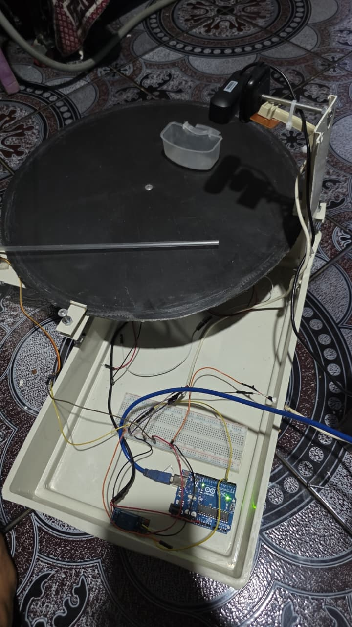

The 4-Step Process
1 | Capture | A fixed overhead camera images each unit as the rotating disc carries it past the lens.
2 | Detect | HAWK-YOLO localises any surface defect and classifies the unit as good or defective.
3 | Decide & log | The engine fuses the verdict, stores it in the database, and updates the live dashboard.
4 | Reject | A servo sweeps defective units off the disc through the Arduino / PLC bridge within ~0.1 s.

3.Results & Validation
98.9%  DETECTION ACCURACY (mAP@50) | ~35 ms  INFERENCE PER IMAGE | 98.5%  PRECISION
4. Get Involved
Let's talk.
We are looking for industry partners, investors, and collaborators to take this solution from prototype to deployment.
FOR INDUSTRY  Pilot With Us  Run a real-world pilot at your facility with full support from our team. | FOR FUNDERS  Fund the Next Phase  Help us scale from prototype to commercial deployment — detailed financials available on request. | FOR RESEARCHERS  Collaborate With Us  Co-author research, share datasets, or extend the work into new domains.

CONTACT THE TEAM
Team members | . Marwa Mohamed – 240102975 · Norhan Rafik – 240102862  · Doha Ramy – 240102408 · Alaa Adel – 230105740  · Mahmoud Kamal – 230105825 · Mohamed Abdelrazek – 240102743  · Noor Hany Ragb – 240101062
Supervisor | Dr. Sahar Kamal · sahar.kamal@sut.edu.eg
Project Page / Repo  Qr Code for QMS | https://qms.sut.edu.eg/web/projects/view/70  

This project was developed at El Sewedy University of Technology (SUT) — Egypt's polytechnic university dedicated to applied engineering and industry collaboration. SUT students work on projects connected to real industrial partners across the energy, manufacturing, and technology sectors.

© El Sewedy University of Technology · Polytechnic of Egypt

